Bury St Edmunds Town Trust
Options Report:
11 High Baxter Street Bury St Edmunds Suffolk IP33 1ES
May 2019.

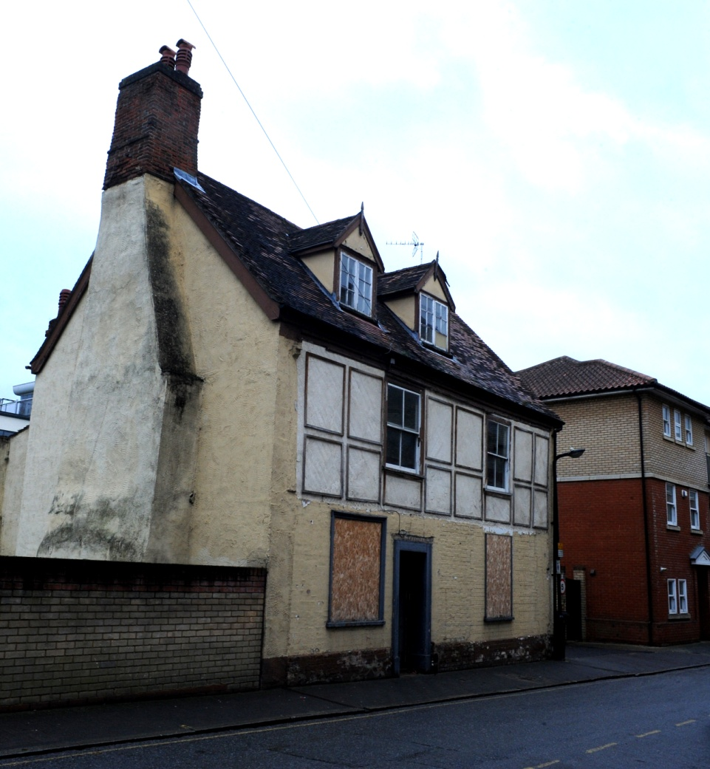

The working group 11 High Baxter Street behalf Bury St Edmunds Town Trust
bcr-Infinity Architects Angel Hill Bury St Edmunds Suffolk.

Contents.
- Introduction
- Aims of the project/ Trust brief
- Executive summary
- Summary History and Significance of the Building
- Description of options – opportunities and constraints
- Costs
- Summary
- Appendix. Schedule of consultations.
- Further reports available
  - Nicholaas Joubert’s Heritage Asset Assessment- July 2017
  - Whitworth – Conditions Report May 2019
  - Drawings of the 3 options – A3 & A4
  - Structural engineers report
  - Quantity Surveyor Budget Estimates for the three options.
  - Red Book valuations from Lacy Scott & Knight 2019.

- Introduction.
The building is in a town centre location in a street now dominated by service areas and car parks. Now marooned next to unsympathetic developments. The building continues to be in disrepair which in itself creates further blight on the street. It is one of the few remaining problem and neglected historic buildings in Bury St Edmunds with little prospect of successful commercial restoration. It has been marketed over several years with no private or developer buyer finding a satisfactory way to refurbish the building.
The Trust feels this building represents an almost unique opportunity to reveal a very early building in the history of the Town. The centre of Bury St Edmunds is a thriving mixed use environment which means that, generally, any property of this type which comes onto the open market is quickly snapped up, whether it be retail or residential, but especially the latter. 11 High Baxter Street is the last medieval building left in the town centre which requires ‘saving’ and putting into a long term viable use. All of the others are in such uses, perhaps a tribute to both the concern of the townsfolks for their historic buildings but also the economic buoyancy of this remarkable town. So this is the last medieval building which will be refurbished and, as such, it provides the last opportunity for the history and importance of such a building to be explored as a live project which can involve the whole community.
The building is in the Bury St Edmunds Town Centre Conservation Area and is further protected by being Grade II listed. It’s designation description says:
House. C17 core with C18 and C19 exterior. Timber-framed, part roughcast, part brick faced. Square roughcast panels to the upper storey of the front; painted brick to the lower storey. Plaintiled roof with a moulded timber eaves cornice. Probably originally jettied on the front and along the south gable: a bulge along the gable wall lines up with the top of the brickwork, which may underbuild a jetty along the front. Now in an isolated position as the sole survivor of a former continuous row of buildings along the east side of High Baxter Street. EXTERIOR: 2 storeys and attics: 2 window range: sashes with a single vertical glazing bar in flush cased frames. 2 gabled dormers in the front slope of the roof with plain bargeboards and spike finials have small-paned 2-light casement windows. 2 dormers also in the rear slope. An off centre entrance door in a plain wood doorcase with flat cornice hood. The chimney-stack at the north end has a shaft of Tudor bricks. INTERIOR: plain main cross-beams exposed on the ground floor and in one upper room the wallplates and main beams. The timbers are plain with chamfers. The roof was renewed in the C18, when an extension along the rear widened the building.
While described as having C17th core with C18th and C19th exterior Nicolaas Joubert’s Heritage Asset Assessment explains the building’s roots are far earlier in the 15th C and while having under gone later remodellings over a very long period, its origins are still legible. The history and special interest of the building is explained further in section 4.

Bury St Edmunds Town Trust (BTT) completed the purchase of the property in January 2019. The house had been under consideration by BTT for sometime and an offer made some 12 months ago. Negotiations on several technical issues delayed the purchase (including potential contamination from a previous garage use next door, resolved by the Trust working with the Local Authority and confirmed by solicitors) however the BTT are very happy with the purchase of one of the few remaining un-refurbished medieval houses in the town.
The Heritage Asset Assessment carried out in 2017 for a previous owner explained the significance of the building and demonstrated the potential for the building
BTT is ideally suited for this project work as it has a long history of bringing listed buildings back into an appropriate use (Trust formed in 1979 please see web site for further information on projects completed; www.burystedmundstowntrust.org.uk)
Members of the Board have many years experience working on listed buildings and working with teams of surveyors, engineers and architects to maximize opportunities for the building.
The first phase of this work carried out since purchase has during RIBA stages 0-1 and this has included:
- Condition survey carried out by Whitworth Co-Partnership Architects
- Option Appraisal of potential plan formats and uses by bcr-infinty Architects
- Structural Survey
- Quantity surveyors review
- Legal and search fees
- Red book valuations on options – Lacy Scott & Knight
- Working group meetings with BTT and professional team
- Contact with stakeholders including local authorities, neighbours, press, educational establishments and conservation officer.

- Aims of the project - Trust brief
The Trust aims to fulfill the charities objectives;
“To preserve for the benefit of the people of the former Borough of St Edmunds in the county of Suffolk and the Nation, the historical, architectural and constructional heritage that may exist in and around the former Borough of Bury St Edmunds in the county of Suffolk in buildings (including any structure or erection, and any part of a building as so defined) of particular beauty or historical, architectural or constructional interest”
To do this by following best practice guidance on historic buildings and sustainability targets that we hope will enable the refurbished building to be an exemplar project for others to follow and learn from.
Working with other stakeholders the Trust will work with West Suffolk College and other education establishments to increase knowledge about our listed buildings and and provide opportunities for training and work experience for construction trade and design students. This will fit into our existing sponsorship of scholarships for construction students.
During the options stage we will be considering and exploring a range of options for the building including rental market for single accommodation via organisations such as The Nehemiah Project, YMCA, Emmaus etc. These we will market test with local agents for letting values against other options to sell on as a part refurbishment or full renovation with extension.

- Executive Summary
- At the conclusion of the option appraisal the working group recommended we proceed with the option with an extension.
- This option would be challenging to deliver within a cost budget and may result in a conservation deficit.
- We would reduce the financial risks by a combination of early marketing of the property (previously worked for the Trust where new owner finished the property) and reviewing completing the phases as series of works packages.

- Summary History and Significance of the Building
The Trust has two reports that describe the building, it’s history of development, the significance of its fabric and it’s condition these are included in the reports:
Nicolaas Joubert- Heritage Asset Assessment 2017
Whitworth Architects- Condition Report January (updated May 2019) 2019.
The Planning (Listed Buildings and Conservation Areas) Act 1990 is the legislative basis for decision-making on applications that relate to the historic environment. Sections 66 and 72 of the Act impose a statutory duty upon local planning authorities to have ‘special regard to the desirability of preserving listed buildings, their settings or any features of special architectural or historic interest which they possess’ and to ‘pay special attention to the desirability of preserving or enhancing the character or appearance of conservation areas’.

In considering applications for listed building consent or planning permission, local authorities are also required to consider the policies on the historic environment set out in the National Planning Policy Framework 2018. At the heart of the Framework is ‘a presumption in favour of sustainable development’ and there are also specific policies relating to the historic environment. The Framework requires local authorities to ‘recognise that heritage assets are an irreplaceable resource and conserve them in a manner appropriate to their significance’.
So it is imperative that any proposal to alter a listed building is informed by the significance of the building.
Nicolaas Joubert explains there were at least five phases of development of the house following it’s late 15th C construction and these were: late 16th C to early 17th C; early 18th C to early 19th C; late 19th C; and 20th C.
He explains that the house was origninally built in two long bays of timber-framing and on the basis of a carpentry joint as well as general impressions a date in the late 15th century is likely. Historic maps show that No 11 was part of a continuous building line along the street and indeed a terrace on this east side of High Baxter Street survived even until the 1960s. There is physical evidence for truncation to number 11 on both sides and it is likely that the timber-framed bay system continued to right or left, or both as part of the 15th C building phase.

A summary of the ‘special interest’ or significance of the building’s fabric might be best explained thus:
Highly Significant- Any fabric which remains which is of the primary phase of construction is extremely significant as it explains the origins of the building and helps explain the history of its location.
Significant- Fabric which explains the palimpsest of significant changes which have affect the building would fall into this category. This includes historic features such as the chimney piece in the ground floor north room and the second to first floor staircase and the Tudor bricks on the east elevation.
Not Significant- The 20th C alterations did nothing to enhance (and barely preserve) the historic fabric, rather it covered up and disguised much of the significant fabric and the history of development of the building. In general terms it would be better removed.
Whitworth’s Condition Survey concludes that, while there are some significant issues with the building it remains basically sound and, historic fabric is repairable.

- Design options described with analysis.
The BTT working group initially reviewed a potential long list of possible options and after considering input from a range of expertise reduced this to three options for further study.
Drawings for these have been completed and reviewed by the working group and some changes made. It should be noted that these are not final designs. They have been completed to allow others to review such as structural engineering, quantity surveyors and red book valuations to be completed to aid the decision process and agree a final technical brief for the next stage of work (RIBA stages 2-3).
All of the options were advised by the knowledge of the significance of the building and that, in general terms, pre-20th C fabric was of significance while the more recent parts and elements had no significance. For instance, each option took the approach that the existing staircase from ground to first floor is both modern and unnecessarily precipitous. New designs were informed by further analysis of construction and that the first floor landing was in part also modern fabric. In the same way the rear addition ‘conservatory was seen as dispensable as were the second floor subdivisions
The Options developed were as follows:
5.1 Review an option for a community/charity use for the building.
5.2 Repair and refurbishment using the existing floor plate and a use as a single dwelling.
5.3 As option 5.2 but including the addition of a extension to increase ground floor area and amenities.
Design Statement.
Proposed Renovations to 11 High Baxter Street, Bury St. Edmunds.
This design statement has been produced to describe the reasoning behind the proposals that have been prepared to determine the viability and possibilities for the renovation of 11 High Baxter Street, Bury St. Edmunds.
This exercise was carried out to determine the viability of the re-use of the existing space within the building envelope, retaining the significant historic fabric and internal walls, and utilising the footprint of later additions to the building, as well as adding further extensions to increase the potential floor space and volume of the building.
All of the options would include the sensitive repair and restoration of the significant historic fabric including the 15th C frame and core, and 17th and 18th C remodellings.
Similarly, all of the options would embrace high sustainability measures. These would primarily be applied to the modern extensions proposed, but benign interventions in the historic fabric would also be expected.
The statement covers three options chosen from several initial proposals placed before the trustee committee and represent the two generally agreed principles for the potential re-use of the building.
Option 1. Community Use – Extended.
The first option considered was to adapt the existing building to fit a variety of community based uses that would call for flexible spaces and amenities to satisfy the requirement for a building used for assembly and recreation.
The ground floor area of the existing building would retain the existing central separating wall, running from the front to the rear façade, together with the two existing doorways within the partition. The internal partition connecting the gable to the cross partition which formed a front and rear room space will be removed to create a single room with a dual aspect onto High Baxter Street and into the rear garden area. This room could accommodate a small kitchenette to allow for the space to be used as a “pop up” café area.
The stud wall which runs parallel to the separating partition, forming a corridor link from the main entrance to the rear of the building, would be removed allowing for the existing entrance door from High Baxter Street to open into an enlarged entrance lobby.
The two brick and glazed mono pitched single storey rear extensions to the building would be replaced by a new dual pitched single storey construction which would occupy the same width of the original lean to elements and would extend along the entire length of the North garden wall and would also return down the length of the East garden wall to create a wrap around extension on two sides of the enclosed garden space.
The accommodation provided within the proposed extension would allow for an area along the northern side of the building which could accommodate a single or two small workshop areas accessed via a link from the rear of the existing building to the eastern side of the rear extension which would accommodate the sanitary installations, sized to suit the potential accommodation levels of the community uses.
The link would also provide glazed access into the remaining enclosed courtyard, providing usable external space.

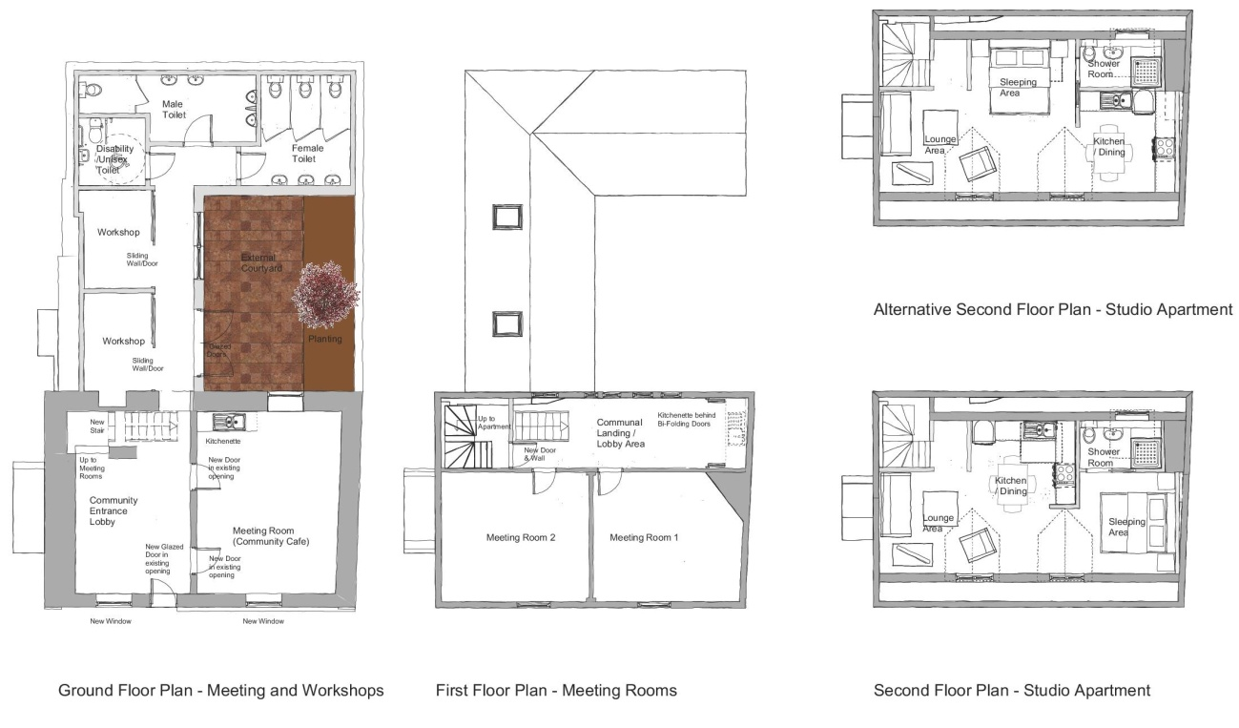
The existing ground to first floor stair would not be acceptable for usage as a public stair, and as with the other design options, it will be necessary to install a new stairway up to the first floor in the same position as that of the existing stair, but rotated to lift from the gable side of the proposed entrance lobby, directed up into the centre of the first floor rear landing area.
As before, this re-configuration will improve both the circulation at ground level, where the access to the rear extension will be improved, even though the headroom under that stairs will be restricted to a degree, and at first floor level where the stair will land within a larger landing area and not within the cramped confines at the base of the existing stair leading up to the second floor.
To accommodate this stairway within the confines dictated by the original floor structure, and to avoid additional cutting out of the first floor deck, it will not be possible to ensure that the new stair is installed in complete compliance with the current building regulations, for both stair riser height and headroom.
The space below the stairs, which presently provides access to, what is believed to be a small cellar space, will be enclosed with no access from the ground floor.
At the first floor level, the present layout of timber and plasterboard framed partitions added to create the access corridor and toilets and shower rooms would be removed to create a large landing area. This space will be re-planned to allow for potential installation of a small enclosed kitchenette accessed directly from the landing area.
The original separation wall between the landing space and the two rooms facing onto High Baxter Street, as well as the wall between the two rooms, will be retained and renovated, as will the doorway access into the two adjacent rooms. These spaces will be renovated to create two new meeting / exhibition rooms.
The existing winding staircase from the first floor to the second floor will be retained and renovated, with new handrails added. This staircase will need to be separated from the landing area at first floor with a full height enclosure wall and new access door. This will be required to provide fire protection and separation between the public usage area at this level and the domestic use that is proposed at second floor level.
All the timber and plasterboard partitions which form the various rooms on the second floor will be removed together with all fittings. This level will be re-planned to form a studio apartment with an open plan space for living and dining and a sleeping area. A small kitchen area and separate shower room/ toilet would be created. The available space at second floor level will allow for a degree of flexibility when it comes to designing the final internal layout.
This proposal shows that options are available to create an alternative community use for the building when allied to a degree of additional extended space. The design proposal produced has followed the same strictures regarding the need to minimise the removal or alteration to the existing building fabric, due to the listed nature of the property.
To allow the building to be utilised for community use, the proposal would need to show compliance with the building regulations and fire precaution regulations and due to the nature of the usage type, namely open to the public, the regulations will be more intrusive and onerous that that required for a domestic situation.
To create a renovation that affords the type of amenities proposed for a community use, the requirements to show compliance with the building and fire regulations may require alternative options be explored to show compliance that could necessitate a greater degree of removal and remodelling of the internal fabric and fixtures, such as the stairs, to allow the building to achieve compliance and certification.

Option 2 . Single Dwelling – Not Extended.
This option was chosen to determine what could be achieved by using only the original building shell and the footprint of the two single storey lean to elements contained within the rear yard.
The proposal re-imagined the ground floor plan of two main rooms. The existing entrance from High Baxter Street would be retained and the door would open directly into a new entrance lobby / study / dining area created by the removal of the existing timber and plasterboard wall that created a narrow corridor to the rear of the building and the stair.
The two rooms to the right side of the ground floor will be amalgamated into a single day room / lounge area by the removal of the separating timber and plasterboard stud wall, allowing the room to have a twin aspect, and could allow for a direct access into the rear garden from the lounge via a newly created glazed doorway within the width of the existing rear window.
The existing main separating wall running from the front to the back of the property would be retained and renovated, including the blocking up of the door which originally served the room facing onto High Baxter Street.
The two brick and glazed mono pitched single storey rear extensions to the building would be replaced by a new dual pitched single storey construction which would house a new kitchen / breakfast area and small utility room. There would also be a small external store incorporated within this new extension.
The dual pitch roof would allow for roof windows to being natural light into the kitchen area below.
A new staircase is proposed to replace the existing stair. This stair will rise from within the new entrance hall / dining area and be oriented to rise from the gable end of the building towards the centre of the space. This will improve both the circulation at ground level, where the access to the rear extension will be improved, even though the headroom under that stairs will be restricted to a degree, and at first floor level where the stair will land within a larger landing area and not within the cramped confines at the base of the existing stair leading up to the second floor.
Due to the restricted space available within the limits of the original fabric, the new stair will fall outside being compliant with the present building regulation and will need to be subject to a relaxation from the constraints of Part K of the building regulations, for both stair pitch and available headroom.
The space below the stairs, which presently provides access to, what is believed to be a small cellar space, will be enclosed with no access from the ground floor.
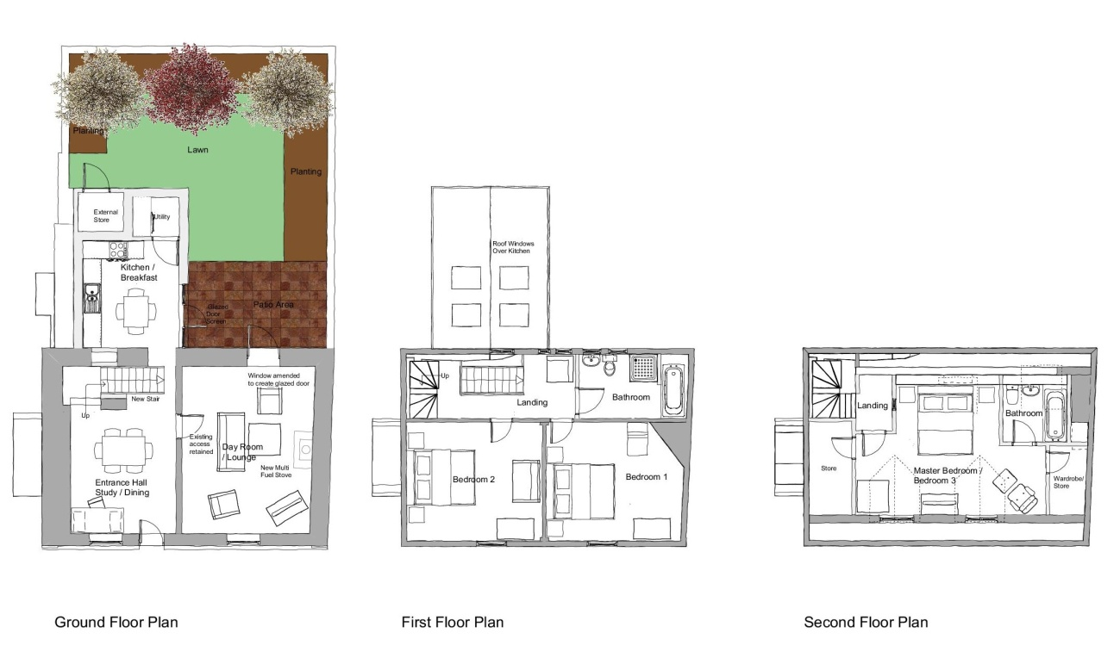
At the first floor level, the present layout of timber and plasterboard framed partitions added to create the access corridor and toilets and shower rooms would be removed to create a large landing area. This space will be re-planned to allow for the installation of a new bathroom accessed directly from the landing area.
The original separation wall between the landing space and the two rooms facing onto High Baxter Street, as well as the wall between the two rooms, will be retained and renovated, as will the doorway access into the two adjacent rooms. These spaces will be renovated to create two new bedrooms.
The existing winding staircase from the first floor to the second floor will be retained and renovated, with new handrails added. All the timber and plasterboard partitions which form the various rooms on the second floor will be removed together with all fittings.
This space will be re-planned to create a new master bedroom, with an
en-suite bathroom, an entrance lobby space at the top of the stairs and storage cupboards built into the design.
This proposal will produce a family dwelling, with an enclosed garden amenity space, separate kitchen / Breakfast room, lounge and dining room, together with three double sized bedrooms.
This proposal will need to comply, as close as possible, with the current building regulations for domestic usage. We have noted above that working within the constraints of the existing building fabric will require some flexibility to be shown for certain aspects of the proposals due to the listed nature of the building.
The existing ground to first floor stair would not be acceptable for usage as a public stair, and as with the other design options, it will be necessary to install a new stairway up to the first floor in the same position as that of the existing stair, but rotated to lift from the gable side of the proposed entrance lobby, directed up into the centre of the first floor rear landing area.
As before, this re-configuration will improve both the circulation at ground level, where the access to the rear extension will be improved, even though the headroom under that stairs will be restricted to a degree, and at first floor level where the stair will land within a larger landing area and not within the cramped confines at the base of the existing stair leading up to the second floor.
To accommodate this stairway within the confines dictated by the original floor structure, and to avoid additional cutting out of the first floor deck, it will not be possible to ensure that the new stair is installed in complete compliance with the current building regulations, for both stair riser height and headroom.
The space below the stairs, which presently provides access to, what is believed to be a small cellar space, will be enclosed with no access from the ground floor.
At the first floor level, the present layout of timber and plasterboard framed partitions added to create the access corridor and toilets and shower rooms would be removed to create a large landing area. This space will be re-planned to allow for potential installation of a small enclosed kitchenette accessed directly from the landing area.
Option 3 . Single Dwelling – Extended.
The third option proposed is an enlargement of the design and layout shown above in Option 2.
This option retains the same internal layout proposed for the original building shall but proposes an increase in the size of the single storey rear extension. The extension will retain the width of the previous proposal but will expand to enclose the whole of the north of the garden walls far as the east wall.
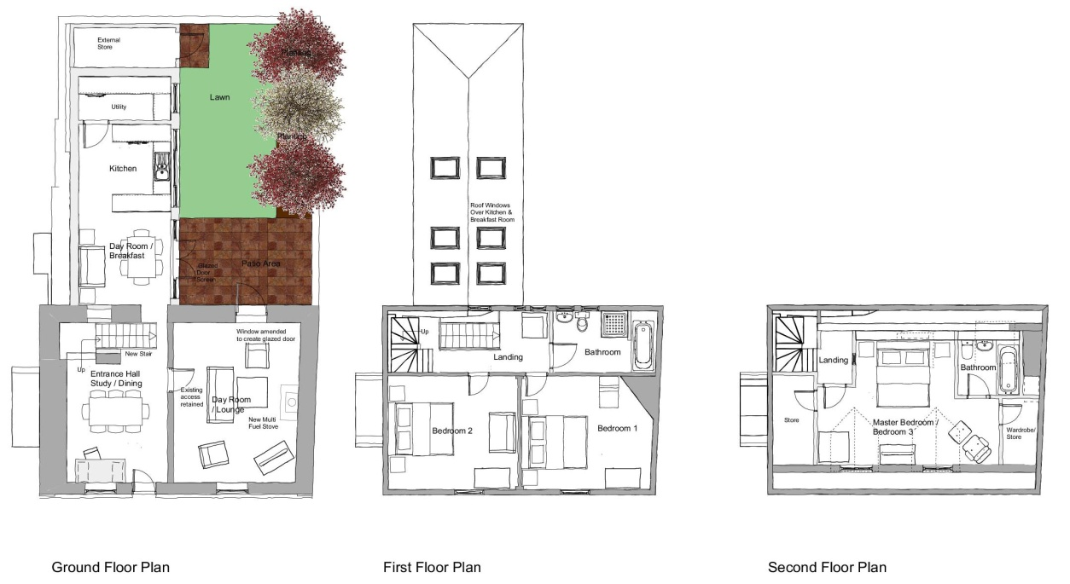
Internally the breakfast area will expand to create a family room and an enlarged kitchen would be created, together with a larger utility room and an external store abutting the eastern garden wall.
As with the smaller extension design, the roof profile will allow for additional roof windows to be included to provide natural light into the kitchen and the family room / breakfast space.
The first and second floor layouts would replicate the proposal described in Option 2 above.
- Costs
Please see Quantity Surveyor Budget Estimates 1-3 for detail.
- Summary

A great deal of work has been carried out over the past 4 months since the Trust purchased the building. The reports and consultations completed demonstrate this. We continue to be delighted with the building and the potential for carrying out a successful refurbishment.
Fortunately we have found no major issues with the building the basic structure is sound and the earlier building materials have been well supported by later additions. However the scope of future building work will be substantial as both external and interior finishes will need to be carefully revealed and treated in a method that will provide a long term sustainable future for the building.
The Trust’s working group will be challenged to do this work with a tight budget and it is hoped members will support them both in experience and financial contributions as we commence the journey to bring this building back to a new life.

